**Design Pattern and Principles**

**Exercise 1: Implementing the Singleton Pattern**

**Logger Class:**

package com.example.singleton;

public class Logger {

private static Logger *instance* ;

private Logger() {

System.***out***.println("Logger created");

}

public static Logger getInstance() {

if(*instance* ==null) {

*instance* = new Logger();

}

return *instance*;

}

public void logMessage(String msg) {

System.***out***.println("Log:" + msg);

}

}

**Main Class:**

package com.example.singleton;

public class Main {

public static void main(String[] args) {

Logger log1=Logger.*getInstance*();

log1.logMessage("LOGGER FIRST MESSAGE");

Logger log2=Logger.*getInstance*();

log1.logMessage("LOGGER SECOND MESSAGE");

if(log1==log2) {

System.*out*.println("Loggers are same");

}

else {

System.*out*.println("Loggers are different");

}

}

}

**Output:**

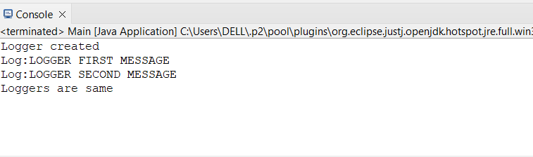

**Exercise-2: Implementing the Factory Method Pattern**

**1.Document interface:**

package factoryMethod;

public interface Document {

void docType();

}

**2.Word Document class:**

package factoryMethod;

public class WordDocument implements Document {

public void docType() {

System.***out***.println("This is WORD Document");

}

**3.PdfDocument class:**

package factoryMethod;

public class PdfDocument implements Document {

public void docType() {

System.***out***.println("This document type is in PDF format");

}

}

**4.ExcellDocument class:**

package factoryMethod;

public class ExcelDocment implements Document {

public void docType() {

System.*out*.println("This is EXCELL SHEET");

}

}

**5.DocFactory**

package factoryMethod;

public class DocFactory {

public static Document getDocType(String type) {

if(type.equals("word"))

return new WordDocument();

else if(type.equals("pdf"))

return new PdfDocument();

else if(type.equals("excell"))

return new ExcelDocment();

else

return null;

}

}

**6.Main class**

package factoryMethod;

public class Main {

public static void main (String [] args) {

DocFactory f = new DocFactory();

Document d1= f.*getDocType*("word");

d1.docType();

Document d2=DocFactory.*getDocType*("pdf");

d2.docType();

Document d3=f.*getDocType*("excell");

d3.docType();

Document d4=f.*getDocType*("jpg");

if(d4==null)

System.***out***.println("Type is not there!!!!!");

}

}

**Output:**

